**Eng. George Mulamula:**

Eng. George Mulamula is currently the founder and CEO of the Dar Teknohama (ICT) Business Incubator (DTBi) for entrepreneurship & innovation hosted at the Commission for Science & Technology, the only tech incubator in the country. He is also the Senior Government Advisor on ICT entrepreneurship & innovation for an enabling environment and eco-system. Prior to that he was the first Principal Deputy Chief Executive Officer of the Rwanda Development Board (RDB) and Senior Advisor in the Ministry of Commerce & Industry in Rwanda and worked on their SME and Entrepreneurship Policy. He was also the Senior ICT Advisor in the Government of Rwanda and in that capacity, the Lead Policy Advisor on the Rwanda National Information Communication Infrastructure Policy Plan II and WSIS Document preparation. George Mulamula was for over 8 years the first Africa Technical Expert in Intellectual Property (IP) Automation with the World Intellectual Property Organization (WIPO), based in Geneva, Switzerland and worked with Sub-Sahara African Governments on the utility of ICT in IP innovation. He also was a catalyst in transforming the African Advanced Level Telecommunications Institute in Nairobi, Kenya to be a Centre of Excellence for the International Telecommunications Union. He has run ICT companies and has written extensively on ICT, Technology Transfer for Sustainable Development, including lecturing at Higher Learning Institutions in East Africa. He is a Mentor and Coach for entrepreneurs and has conducted pitching sessions around the country and outside the country, including at Global Entrepreneurship Summits, GIST boot camps in Tanzania & South Africa, Unreasonable East Africa and Demo Africa. He is the Chair of the Tanzania Airtel Fursa judging team for youth entrepreneurship growth, a member of the National mHealth Committee, Board Member of Demeter, a MIT Startup which is going global, on the Advisory Board of the Global Learning XPRIZE in California (USA), a member on the Tanzania National ICT Think Tank and Commissioner on the Tanzania National ICT Commission and member of the Tanzania Financial Services Deepening Trust.

**IBANGA UMANAH**

Ibanga defines Brave’s strategy, product design, and operational systems. He believes what separates good teams from great ones is their rate of learning. Brave's AI tool for talent matching works to build those hyper learning teams. Before Brave, he helped Fortune 100 companies build new businesses at Jump Associates. In addition to Brave, Ibanga lectures around the world on design and leadership, serves on new venture boards, and teaches skiing to anyone willing to fall in love with snow.

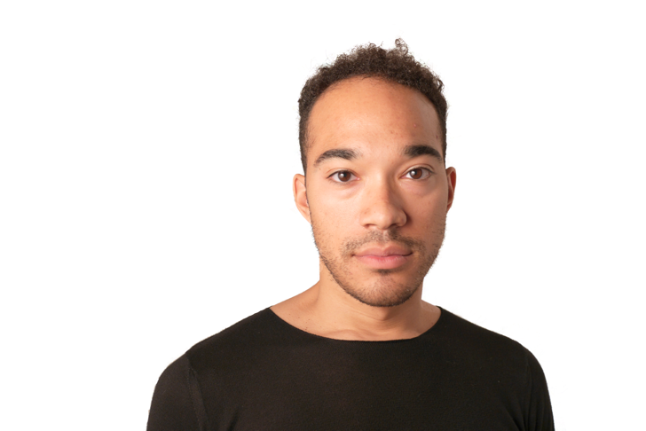

**Dylan Lennox**

Dylan Lennox is an experienced Executive having demonstrated success in launching and managing Mobile Money operations in Tanzania (2008) and Mozambique (2013) with Vodacom M-Pesa. Until December 2015 Dylan was the Managing Director of M-Pesa in Mozambique, with complete P&L ownership and responsibility for the strategy, execution and general management of the sales, distribution, marketing, business development, product development, finance, customer operations, compliance and risk management functions.

Previously he was responsible for starting up and running the commercial operations of Vodacom M-Pesa in Tanzania as Managing Executive: New Technologies and later Chief Officer: M-Commerce, from June 2007 until he left in September 2012. Tanzania is widely recognized as one of the leading mobile money markets in the world with Vodacom M-Pesa the leader in a highly competitive environment with greater than 6 million monthly active customers.

Dylan is a Chartered Accountant (SA) who also has significant experience and expertise in starting up and leading telecoms revenue assurance, billing integrity and product development functions in South Africa, Tanzania and Mozambique.

He is a partner of MFX.

**Enaisia Avontuur**

A professional Business Analyst with general and project management expertise who enjoys being part of, as well as leading, a successful and productive team. Commercially astute and experienced in many aspects of, Business analysis, IT development and Financial Services including business case development, CRM and mobile money solutions. Possesses excellent interpersonal skills and can communicate concisely at all levels.

